Player # : Username : /20

QUIZ

Answer by circling the right answer. Each right answer is worth 1 point, each wrong answer -1 point, each unanswered question 0 point (minimum grade 0). This sheet has two sides. The use of any game material (books, cards, etc.) is prohibited.

Rules quiz (/10):

1. What happens when a Cavalry model charges model X and destroys X with an Impact attack?
a) The Cavalry model stops and can redirect attacks on other targets. | c) The Cavalry model continues moving until max movement, then can redirect attacks on other targets.
b) The Cavalry model stops and ends its activation. | d) The Cavalry model continues moving until max movement, then ends its activation.

2. When promoting a new Leader in a unit, can you change the model’s facing?
a) Yes | b) No

The eight following questions all refer to the diagram below. All models close enough to be B2B are B2B.
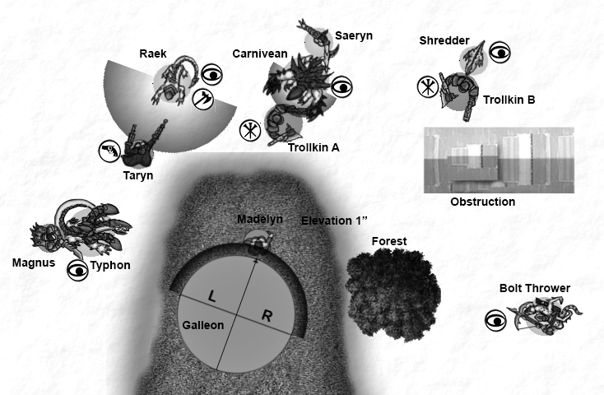

3. Typhon tramples towards Madelyn. Magnus’ Mechanikal Arm has the Knockdown ability. Assuming it has enough movement, can Typhon move in B2B with Madelyn?
a) Yes | b) No

4. The Shredder is damaged. He does one damage point to Trollkin B and uses Snacking (When this
model boxes a living model with a melee attack, this model can heal d3 damage points. If this model heals, the boxed model is removed from play.). Can Trollkin B make a Tough roll?
a) Yes. | b) No.

5. The Carnivean double-hand-throws the Trollkin A targetting Madelyn. If the Carnivean hits Madelyn, where does the Trollkin land?
a) At the maximum distance in a straight line, prompting Least Disturbance moves. | c) Directly in front and in B2B of Madelyn.
b) On top of Madelyn, prompting Least Disturbance moves. | d) The Carnivean has no LOS and cannot target Madelyn.

6. Has Galleon LOS on the Nephilim Bolt Thrower?
a) Yes. | b) No.

7. Has Galleon LOS on Saeryn?
a) Yes. | b) No.

8. What must the maximum height of the obstruction be for the Bolt Thrower to be able to target Trollkin B?
a) 1.75” | c) 2.5”
b) 2.25” | d) The Bolt Thrower can always target Trollkin B.

9. What must the maximum height of the Forest be for the Bolt Thrower to be able to target Madelyn?
a) 1.75” | c) 2.75”
b) 2.25” | d) The Bolt Thrower can always target Madelyn.

10. Can Taryn target the Raek with a ranged attack?
a) Yes. | b) No.

Background quiz (/10) :

11. Of the alliances below, which one does NOT appear in the Colossals story?
a) Cygnar and Khador | c) Cryx and Khador
b) Protectorate and Cygnar | d) Protectorate and Mercenaries

12. In Colossals, Orsus Zoktavir makes a Cygnar warcaster prisoner. Which one?
a) Darius | c) Siege
b) Nemo | d) The Butcher makes no prisoners.

13. What does the new title of Kreoss, Intercessor, imply?
a) He provides justice in the name of the Hierarch. | c) He is the only one allowed to carry the Hierach into battle.
b) He commands all of the martial orders of the Protectorate in war. | d) He serves the Hierarch his breakfast.

14. Who ordered the construction of the Galleon?
a) Bartolo Montador | c) Both Bartolo and Magnus.
b) Magnus | d) None of them.

15. Apart from the Kraken, which Colossal is the oldest?
a) Conquest | c) Judicator
b) Hyperion | d) Stormwall

16. How many Archangels were created on Everblight’s “first run”?
a) 2 | c) 4
b) 3 | d) 5

17. Which confrontation does NOT take place in Gargantuans?
a) Trollbloods vs. Circle | c) Legion vs. Circle
b) Skorne vs. Retribution | d) Minions vs. Circle

18. Which warlock does Kromac leave for dead at the end of Gargantuans?
a) Borka | c) Hoarluk
b) Madrak | d) Grim

19. What is a Vanar Liberator?
a) A member of a group formed to put Queen Ayn Vanar on the throne of Khador. | c) A experimental Khadoran warjack.
b) A member of a group formed to overthrow Empress Ayn Vanar. | d) A rifle.

20. One of the Scions of Thamar, usually evil semi-deities, is also considered the hero of a specific group of non-Thamarite people. Which one?
a) Scion Ekris, patron of Infernalists. | c) Scion Stacia, patron of Arsonists.
b) Scion Delesle, patron of Necromancy. | d) Scion Khorva, patron of Assassins.

